Free GP Community Support Service  Ask your GP or surgery staff to make a referral on your behalf alternatively complete the self-referral and hand in at reception to receive this free service  For more information about this service please call Zoe Dunster on 077031 87811,  or Karen Disney on 07814 131101.  E-mail: GPSupportTeam@alliancehomes.org.uk | 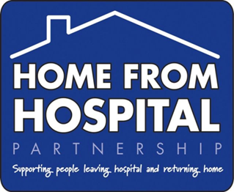  Improving health & wellbeing  GP Community Support  Working in partnership with your GP Surgery to improve community and wellbeing
Free GP Community Support Service  Initial Referral Form  Date of Referral:  Title: First Name: Last Name:  Address:  Post Code:  DOB: Male: Female:  Home Tel No: Mobile:  Email:  Referrer Name: (If not Self) Referrer Contact No:  Referrer Title/ Job Role (if not self) Referrer Email:  Surgery: GP  Reason for  Referral: |  | Working in partnership with your GP  to support you with…….  - Making choices about your housing situation.  - Helping you settle successfully into your new home; for example, finding furniture, household items and setting up utility accounts.  - Developing skills so you can manage in your home.  - Claiming relevant welfare and other benefits and/or grants.  - Dealing with rent arrears and other problems.  - Accessing other services that you may need. For example, Health and Social Care or specialist debt advice services or services to support carers.  - Accessing education, training and employment opportunities.  - Support to return home following a stay in hospital including pre-planned procedures.  - Making sure that you have food and other essential supplies.  - Help with home adaptations and equipment such as key safes and handrails that will make your home safer for you.  Helping you to find opportunities to overcome loneliness and isolation.

